 | 
COUNCIL ASSESSMENT BRIEFING REPORT TO PANEL
HUNTER AND CENTRAL COAST REGIONAL PLANNING PANEL

PANEL REFERENCE & DA NUMBER | PPSHCC-270 – DA/1288/2023
PROPOSAL | Demolition, decommission, remediation and earthworks
ADDRESS | Lot 2 DP 614183  21A Wangi Road, Myuna Bay
APPLICANT | Department of Regional NSW
OWNER | The State Sporting Venues Authority
DA LODGEMENT DATE | 5 September 2023
APPLICATION TYPE | Crown DA
REGIONALLY SIGNIFICANT CRITERIA | The development is Crown development and is being referred to the Regional Planning Panel under the provision of Section 4.33(2)(b) of the Environmental Planning and Assessment Act 1979 – Determination of Crown development applications.
CIV | $3,391,329
LIST OF ALL RELEVANT PLANNING CONTROLS (S4.15(1)(A) OF EP&A ACT) | - Environmental Planning and Assessment Act 1979  - State Environmental Planning Policy (Biodiversity and Conservation) 2021  - State Environmental Planning Policy (Resilience and Hazards) 2021  - State Environmental Planning Policy (Transport and Infrastructure) 2021  - Lake Macquarie Local Environmental Plan 2014  - Lake Macquarie City Council Development Control Plan 2014.
TOTAL & UNIQUE SUBMISSIONS | A total of six submissions were received which included five unique submissions.
DOCUMENTS SUBMITTED FOR CONSIDERATION | - Statement of Environmental Effects – Amended Statement of Environmental Effects  - Site Plans – Site Plans – Appendix A  - Biodiversity Assessment report – Appendix B Myuna Bay Aquatic Biodiversity and Water Quality Assessment  - Biodiversity Assessment report – Appendix C Myuna Bay Sport and Recreation Centre BAR  - Heritage impacts Statement – Aboriginal cultural heritage report – Appendix D  - Other – Appendix E Hazardous materials register  - Contamination and/or remediation action plan – Appendix F – Detailed contamination assessment and remedial action plan  - Acid sulfate soil report – Appendix G – ASS Management Plan  - Other – Appendix H – Council Pre-lodgement minutes  - Other – Civil Drawings REV J  - Other – Scope of Works
PREVIOUS BRIEFINGS | N/A
ASSESSMENT STATUS | Under assessment and preparing for determination - seeking Panel feedback prior to determination.
PREPARED BY | Glen Mathews, Principal Development Planner
DATE OF REPORT | 9 February 2024

- THE SITE AND LOCALITY
  - The site
The site comprises one large parcel of land which contains the former Myuna Bay Sport and Recreation Centre and four smaller non-contiguous parcels of land which are separated from the main parcel by roads (refer to Figure 1). No works are proposed within these smaller parcels of land.
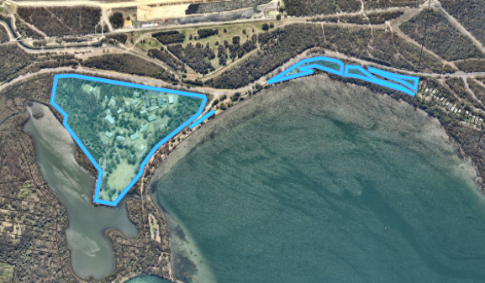
Figure 1 - The site, comprising five individual portions outlined in blue
The main site is zoned SP3 Tourist under the Lake Macquarie Local Environmental Plan (LMLEP) 2014. Works are also proposed in the Crown land adjoining the site which is zoned C2 Environmental Conservation, RE1 Public Recreation and W1 Natural Waterways (Whiteheads Lagoon) (refer to Figure 3).
The site currently contains a large number of buildings and structures associated with the former Myuna Bay Sport and Recreation Centre, including carparks, accommodation lodges, and outdoor activity spaces. The former Myuna Bay Sport and Recreation Centre was operated as a sport and recreation facility since the 1940s, and included overnight accommodation for shorts stays and group camps.
The Myuna Bay Sport and Recreation Centre was closed to the public by the NSW Government in 2019 following safety concerns of potential failure of the Eraring Ash Dam, located approximately 350m north of the site.
  - The locality
The immediate locality contains a diverse range of land uses (refer to Figure 2).
The northern edge of the site adjoins Wangi Road with direct vehicle access provided.
To the north of Wangi Road is Eraring Power Station and associated ash dam. The area is zoned SP2 Infrastructure, with zoning maps specifically identifying the area for electricity generating works.
The south west boundary of the site adjoins Whiteheads Lagoon, and to the south east is public reserve and Lake Macquarie.
In the wider context, to the south a scout camp is located on the southern side of Whiteheads Lagoon, and a large lot residential area is located 500m south of the site.
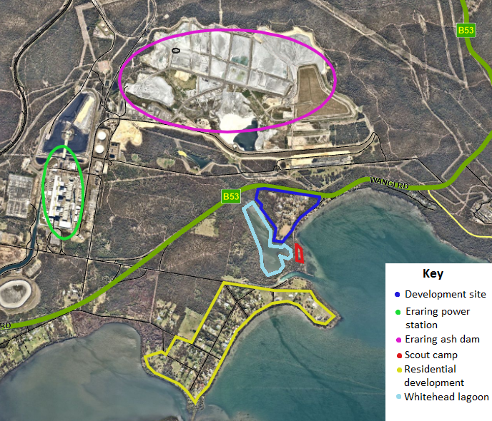
Figure 2 – Site and surrounding context

- THE PROPOSAL AND BACKGROUND
  - The proposal
The proposal seeks consent for demolition of buildings and structures associated with the former Myuna Bay Sport and Recreation Facility and subsequent environmental protection works.
This includes:
Demolition
- Demolition and removal of above ground structures, including free standing equipment and tanks.
- Inground structures (i.e. swimming pool and sewer tanks) to be filled in.
- Inground and aboveground services capped, made safe and abandoned in-situ.
- Incoming services to be terminated.
- Demolition and removal of structures in or adjacent to Whitehead Lagoon, including structures listed on Crown Land Licence.
Site works
- Demolition and removal of hardstand and parking areas (excluding carpark 6 and main internal access road).
- Minor site regrading to install stormwater controls, as necessary.
- Remediation of identified contamination.
- Stabilisation of disturbed areas of the site.
- Installation of concrete vehicle barrier to the west side of the Crooked Creek pedestrian access.
Retention
- The development proposes to retain access from Wangi Road, the main spine road access and carpark 6 on the southern boundary.
The key development data is provided in Table 1.
Table 1: Key development data
Control | Proposal
Site area | 18.87ha
GFA | N/A
FSR | N/A
Clause 4.6 requests | No
Max. height | N/A
Landscaped area | N/A
Car parking spaces | N/A
Setbacks | N/A

  - Background
The development application was lodged on 5 September 2023.
A chronology of the development application since lodgement is outlined in Table 2.
Table 2: Chronology of the DA
Date | Event
2 August 2023 | Exhibition of the application.
25 September 2023 | Request for information from Council to applicant.
19 October 2023 | Amended documentation provided by applicant.
4 December 2023 | Development application was reported to Council for determination, recommending approval.
7 December 2023 | Councillor site inspection conducted.
11 December 2023 | Councillors resolved to seek Minister’s approval to refuse the development application.
14 December 2023 | Councillors sought Minister’s approval to refuse the development application under Section 4.33(1) of the Environmental Planning and Assessment Act 1979.
21 December 2023 | Applicant requested the development be referred to the regional planning panel for determination under Section 4.33(2)(b) of the Environmental Planning and Assessment Act 1979.

  - Site history
The sport and recreation facility was originally constructed in 1944 as part of the National Fitness and Physical Education Branch.
The development was operated as a NSW Sport and Recreation camp venue until it was closed in March 2019.
Over the history of the site there a number of improvements that have been made to the facilities and surrounds. An exhaustive list of these alterations and additions has not been provided in this report given the application seeks demolition.
The site was abruptly closed by the NSW Office of Sport in 2019 after an independent report determined there was a serious risk to guests and staff arising from the potential failure of the Eraring Power Station ash dam wall in the event of major seismic activity.
The site has been closed to the public since the closure. A significant amount of vandalism and theft has occurred throughout the site.
- PLANNING CONTROLS
The site is split zoned, with the main parcel of the site within the SP3 Tourist zone and the smaller parcels of the site within the C2 Environmental Conservation zone. No works are proposed within the area of the site zoned C2 Environmental Conservation.
Areas adjacent to the site, within Crown lands and Whiteheads Lagoon, are zoned C2 Environmental Conservation, RE1 Public Recreation, and W1 Natural Waterway zones; works are proposed within these areas for the removal of existing jetty and associated foreshore structures.
The application seeks consent for demolition and environmental protections works which are permitted within the respective zones with consent.
The proposal is consistent with the zone objectives.
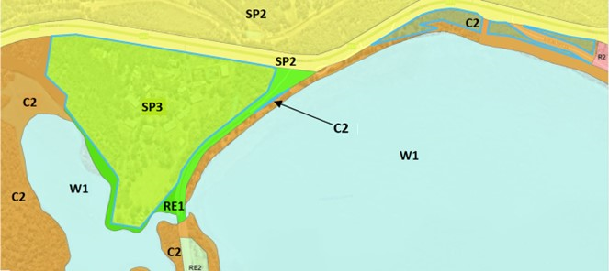
Figure 3 - Site and surrounding lands zoning (site outlined in blue)
A summary of the key matters for consideration from the relevant EPIs are outlined in Table 3.
Table 3: Summary of Key Matters in the Relevant EPIs
EPI | Matters for consideration | Comply
State Environmental Planning Policy (Biodiversity and Conservation) 2021 | Chapter 4: Koala Habitat Protection 2021  Considered as part of a Biodiversity Assessment and there will be no impact on koalas or koala habitat. | Y
State Environmental Planning Policy (Planning Systems) 2021 | The development does not meet any of the prescribed triggers to be considered as regional development. | N/A
State Environmental Planning Policy (Resilience and Hazards) | Chapter 2: Coastal management  - Section 2.7(4) – Development on certain land within coastal wetlands and littoral rainforests area  The development proposes environmental protection works involving removal of structures from the identified coastal wetland and remediation works.  Upon completion of the works, the site will no longer be utilised and the area will be allowed to regenerate, enhancing the overall integrity of the coastal wetland.  The works are environmental protection works and are not designated development.  - Section 2.8(1) - Development on land in proximity to coastal wetlands  Works in these areas will be temporary and support regeneration of the site, with appropriate management strategies provided to ensure no disturbance is caused.  - Section 2.10(1) & (2) - Development on land within the coastal environment area  The proposal will have minimal impact on coastal and environmental values and natural coastal processes.  - Section 2.11(1) - Development on land within the coastal use area  The proposal is consistent with the requirements for the coastal use area.  - Section 2.12 - Development in coastal zone generally  The development does not increase risk of occurrence for coastal hazards.  Chapter 4: Remediation of land  - Section 4.6 – Contamination and remediation to be considered in determining development application  Contamination and remediation has been considered in the Contamination Report and the proposal is satisfactory subject to conditions. | Y
Proposed instruments | No compliance issues identified. | Y
Lake Macquarie Local Environmental Plan 2014 | - Clause 2.3 – Permissibility and zone objectives  Development is consistent with zone objectives  - Clause 2.7 – Demolition requires development consent  The application seeks development consent for demolition.  - Clause 5.7 – Development below mean high water mark  The application applies for consent for works below the mean high water mark.  - Clause 5.10 – Heritage conservation  A due diligence report was supplied which demonstrated the proposed works will not impact on any sites of Aboriginal Heritage.  - Clause 7.1 – Acid sulfate soils  An acid sulfate soils management plan was submitted with the application which provides appropriate recommendations for management of the site.  - Clause 7.2 – Earthworks  Subject to conditions, earthworks are considered suitable for the site and unlikely to have any adverse impacts.  - Clause 7.6 - Limited development on foreshore area  The proposed works will not have a negative impact on natural foreshore processes or the amenity of the area.  - Clause 7.21 - Essential services  All connections to external services are proposed to be disconnected as part of this application. | Y
Lake Macquarie Local Development Control Plan | Lake Macquarie Development Control Plan 2014  - Part 6 Development in Recreation and Tourist Zones  - Part 7 Development in Environment Protection Zones  - Part 9.7 Foreshore and Waterway Development | Y

- REFERRALS AND SUBMISSIONS
  - Agency referrals and Concurrence
The development application has been referred to various agencies for comment/concurrence/referral as required by the Environmental Planning and Assessment Act 1979 and outlined below in Table 4.
Table 4: Concurrence and referrals to agencies
Agency | Concurrence / referral | Comments | Resolved
Concurrence requirements - N/A
Referral/consultation agencies – N/A
Integrated Development
NSW Fisheries | Fisheries Management Act 1994 | The applicant has chosen to seek consent under the Fisheries Management Act 1994 external to this application.  This application was not lodged as integrated development.  It is noted the demolition of the water-based structures, including the jetties and ski ramp will not be able to be undertaken until approval has been obtained from NSW DPIE – Fisheries. | N/A
Water NSW | Water Management Act 2000 | While this Act applies, the applicant is exempt as a public authority under the Water Management (General) Regulations 2018. | N/A

  - Council referrals
The development application has been referred to various Council officers for technical review as outlined Table 5.
Table 5: Consideration of Council referrals
Officer | Comments | Resolved
Engineering | Review of remediation and removal of infrastructure. Raised no objections. | Y
Erosion and sediment control | No objection subject to amendments. Amendments requested could be included as conditions of consent. | Y  (Conditions)
Heritage | No objections subject to recommended conditions. | Yes  (conditions)
Flora and fauna | The overall impacts to flora and fauna have been considered through a Biodiversity Assessment and associated management plans. No issues raised subject to conditions of consent. | Y  (Conditions)
Environmental management | Reviewed preliminary and detailed site investigations in conjunction with remedial action plan, and confirm the site will be appropriately remediated / managed. | Y  (Conditions)
Waste management | No response provided; standard conditions for waste management can be provided. | N/A  (Conditions)
Creeks and watercourses | Assessed for compliance with Council’s Protection of Watercourses and Drainage Channels Policy in relation to the potential impacts of the development on natural water systems.  The proposal was supported subject to conditions. | Y  (Conditions)
Lake / foreshore and coastal protection | Considered the development against SEPP (Resilience and Hazards) 2021 – Chapter 2 Coastal Management in conjunction with Aquatic Biodiversity and Water Quality Assessment. No issues raised subject to conditions of consent. | Y  (Conditions)

  - Community consultation
The application was notified in accordance with Council’s Community Engagement Strategy Plan from 2 August 2023 to 23 August 2023, with a further two weeks extension provided until 6 September 2023.
A total of six submissions were received. Five submissions objected to the development and one submission supported the development.
Objections include the following items:
- Removal of waterski club structures including those within Whitehead Lagoon.
- Request review of ash dam’s current stability.
- Other options for use of the site have not been explored.
Refer to attached Council business paper report – standing committee 4 December 2023 which provides consideration of submissions received.
- KEY ISSUES
The development demonstrated an overall compliance with applicable Environmental Planning Instruments, development standards and local controls. However, was considered by the elected Council for matter of the public interest.
In this regard the following key issues are relevant to the assessment of this application:
  - Public interest
The development application was reported to the elected Council in December 2023. Through this process, the elected Council resolved not to support the application and seek the Minister’s refusal to determine the application by way of refusal.
The elected Council resolved to not support the application due to public interest as follows:
- The loss of value of the existing infrastructure to the community in the absence of a proposed replacement facility.
- The need for accessible and publicly operated recreation facilities for the Lake Macquarie area.
- The loss of social capital generated by losing a publicly run facility to service all members of the community.
- The absence of detail for the future use of the site,
- RECOMMENDATION
Following a preliminary assessment of the development application in relation to the development controls, taking into account the issues raised in submissions from the community, Council officers and agencies, the Council considers the proposal can be supported in its current form and can proceed to prepare a final determination report within one month.
- ATTACHMENTS
The following attachments are provided:
- Council business paper report – Standing Committee 4 December 2023
- Amended Statement of Environmental Effects
- Site Plans – Appendix A
- Public Submissions

